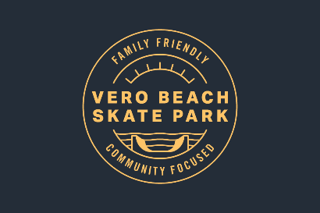
Business Sponsorship Program
Thank you for helping the Vero Beach Skate Park Alliance build a skate park at Leisure Square. With your help, we will build a family friendly, community focused facility for all to enjoy!
Program Details:
* Free To Join
* Your business will sell a product or service with net proceeds going to the Vero Beach Skate Park Alliance.
* Your business will have a link on our website, www.verobeachskatepark.org, and on our FaceBook page promoting you as an official sponsor of the Skate Park.
* On a periodic basis, the proceeds you collect will be sent to VBSPA
VBSPA c/o VBLA
1351 White Heron Lane
Vero Beach, Florida 32963
* Scan and email this form along with your logo to VBSPA at info@verobeachskatepark.org.
* Cancel at any time.
* Once the park is built, your business will be named as one of the contributors to the skate park.
Business Information:
Name of Business_________________________________________________
Address_________________________________________________________
City___________________________________ Zip Code __________________
Website: _________________________________________________________
Owner/Manager, primary point of contact: _____________________________
Phone Number: ___________________________________________________
Program Offer:____________________________________________________

